**Define Company**

Enter Transaction code SPRO in the command field

[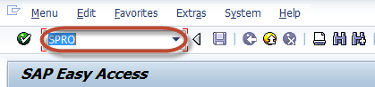](http://www.guru99.com/images/sap/2012/04/comcr01.png)

In the next screen Select SAP reference IMG

[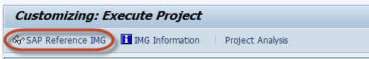](http://www.guru99.com/images/sap/2012/04/comcr02.png)

In next screen Display IMG follow the menu path  
  
SAP Customizing Implementation Guide -> Enterprise Structure -> Definition-> [Financial](http://www.guru99.com/sap-fico-training-tutorials.html) [Accounting](http://www.guru99.com/accounting.html) -> Define Company

[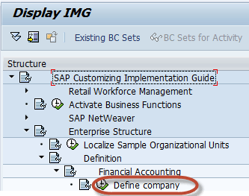](http://www.guru99.com/images/sap/2012/04/comcr03.png)

In the next Screen  
  
1)    Press New Entries

[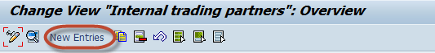](http://www.guru99.com/images/sap/2012/04/comcr04.png)

In the next Screen Enter the Company Details :

1. Enter a unique Company Id for the Company within your corporate group
2. Enter the Company Name
3. In the Detailed Information Section Enter the Company Address details such as Street , PO Box, Postal Code, City
4. Select Country code for country the company is established
5. Select Default language for the Company for Print forms and  Default Texts
6. Select a Local Currency for the Company

[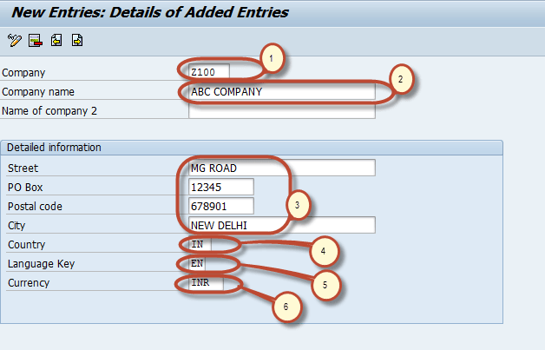](http://www.guru99.com/images/sap/2012/04/comcr05.png)

After completing all the required information ,press save [How to Create a Company](http://www.guru99.com/images/sap/2012/04/savebt.png) Enter your customizing request number

[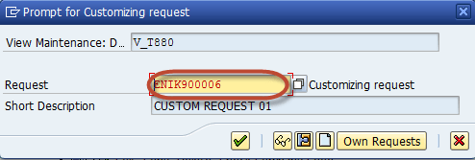](http://www.guru99.com/images/sap/2012/04/comcr06.png)

and your company is created.

## How to Create a Company Code and Assign to a Company

This is a 2 Step Process

1. Define Company Code
2. Assign Company to Company Code

## Define Company Code

Enter Transaction code SPRO in the command field

[](http://www.guru99.com/images/sap/2012/04/comcr01.png)

In the next screen Select SAP reference IMG

[](http://www.guru99.com/images/sap/2012/04/comcr02.png)

In next screen Display IMG follow the menu path  
  
SAP Customizing Implementation Guide -> Enterprise Structure ->Definition->Financial Accounting->Edit, Copy, Delete, Check Company Code

[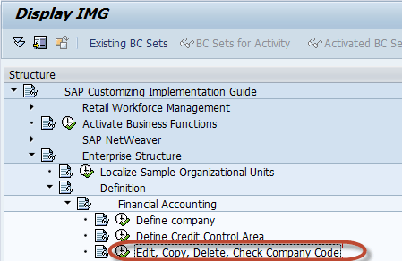](http://www.guru99.com/images/sap/2012/04/comcd03.png)

  In the next screen, select activity -  Edit Company Code Data

[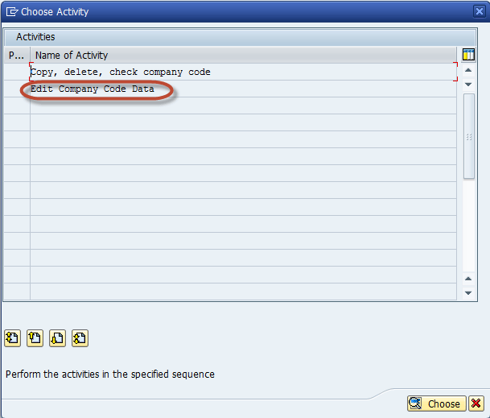](http://www.guru99.com/images/sap/2012/04/comcd04.png)

In the Change View Company code screen  
  
Select New Entries

[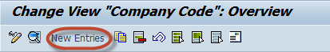](http://www.guru99.com/images/sap/2012/04/comcd05.png)

In the Next Screen Enter the Following Details

1. Enter  your Unique Company Code Number
2. Enter Company Name
3. In the Additional Data section Enter City
4. Enter Country for the Company
5. Enter Local Currency
6. Enter Default Language

[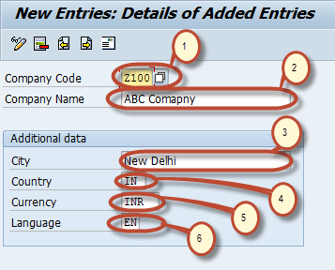](http://www.guru99.com/images/sap/2012/04/comcd06.png)

  Click Address Details button on same screen

[How to Create a Company Code and Assign to a Company ](http://www.guru99.com/images/sap/2012/04/compcdn3.jpg)

Enter Address Details for the Company this will appear in print forms

1. In the Name Section Enter Title and Company Name
2. In the Search Term section Enter Search term 1 and 2
3. In the Street Address section enter street, postal code, city, country
4. In the P O Box Address  section Enter PO Box and Postal Code
5. In Communication Section Enter appropriate details

[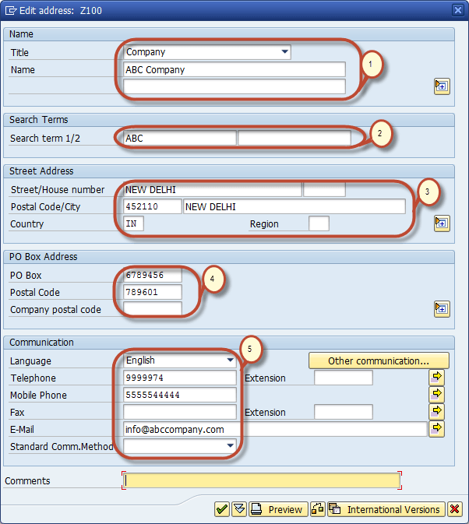](http://www.guru99.com/images/sap/2012/04/comcd071.png)

After Completing this information Press Save [How to Create a Company Code and Assign to a Company ](http://www.guru99.com/images/sap/2012/04/savebt.png) and Enter your Change Request number.

[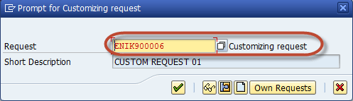](http://www.guru99.com/images/sap/2012/04/comcd08.png)

You have successfully created a new Company code.

## Assign Company Code to Company

In the SAP Reference IMG Select the Menu path  
  
SAP Customizing Implementation Guide ->Enterprise Structure->Assignment->Financial Accounting->Assign Company Code to Company

[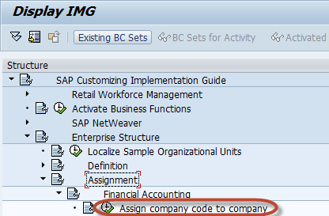](http://www.guru99.com/images/sap/2012/04/comas04.png)

In the Next Screen Enter the unique Company ID against the Company Code you  
  
Want to assign to this Company.

[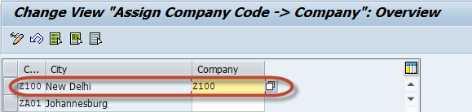](http://www.guru99.com/images/sap/2012/04/comas03.png)

  Press Save [How to Create a Company Code and Assign to a Company ](http://www.guru99.com/images/sap/2012/04/savebt.png) and Enter the Customizing request Number

[](http://www.guru99.com/images/sap/2012/04/comcd08.png)

You have assigned the desired Company code to the Company

## How to Create Chart of Accounts

The following tutorial takes you through the steps to create Chart of Accounts  
  
Enter Transaction code SPRO in the command field

[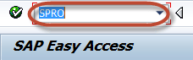](http://www.guru99.com/images/sap/2012/04/COACR07.png)

 In the next screen Select SAP reference IMG

[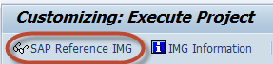](http://www.guru99.com/images/sap/2012/04/COACR06.png)

In next screen-"Display IMG"  navigate the following menu path :  SAP Customizing Implementation Guide ->[Financial](http://www.guru99.com/sap-fico-training-tutorials.html) Accounting -> General Ledger Accounting -> G/L Accounts -> Master Data -> Preparations -> Edit Chart of Accounts List

[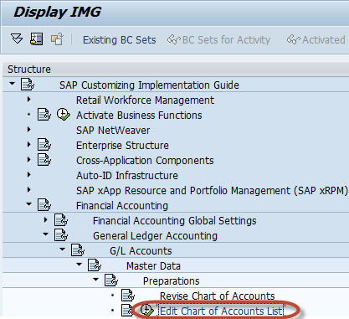](http://www.guru99.com/images/sap/2012/04/COACR05.png)

In the next screen, select New Entries

[How to Create Chart of Accounts](http://www.guru99.com/images/sap/2012/04/COACR04.png)

In the next screen,Enter Following Data :

1. Enter a unique Chart of Accounts Code , maximum length is four
2. Enter a Description for the Chart of Accounts
3. Enter Language in which the Chart of Accounts is created.All accounts have a description in this language.Master Data can only be displayed or maintained in this language
4. Enter the maximum length for G/L Accounts number, it could be maximum to ten digits if number is short then it will prefix zero before it to make it to the  maximum length
5. Enter the type of integration between G/L accounts and cost elements
6. Enter Chart of Accounts  which is used in the corporate group

[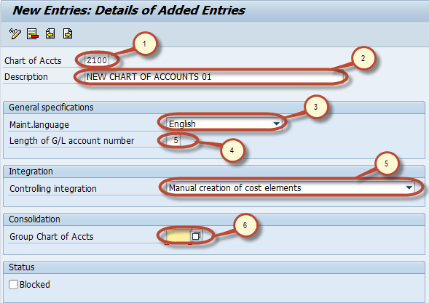](http://www.guru99.com/images/sap/2012/04/COACR03.png)

After you complete entering this information Press Save [How to Create Chart of Accounts](http://www.guru99.com/images/sap/2012/04/COACR02.png).   In the next screen, Enter your Change Request number.

[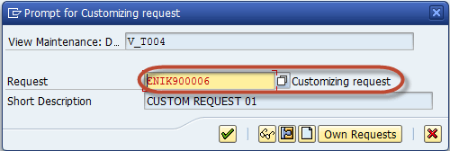](http://www.guru99.com/images/sap/2012/04/COACR01.png)

  You have successfully created a new Chart of Accounts.

## How to Create Chart of Accounts (COA) Account Group

This tutorial takes you through the steps to create a COA Account Group  
  
Enter Transaction code SPRO in the command field

[](http://www.guru99.com/images/sap/2012/04/COACR07.png)

In the next screen Select SAP reference IMG

[](http://www.guru99.com/images/sap/2012/04/COACR06.png)

In next screen-"Display IMG"  navigate the following menu path  
  
SAP Customizing Implementation Guide -> [Financial](http://www.guru99.com/sap-fico-training-tutorials.html) Accounting -> General Ledger Accounting  
  
-> G/L Accounts -> Master Data -> Preparations -> Define Account Group

[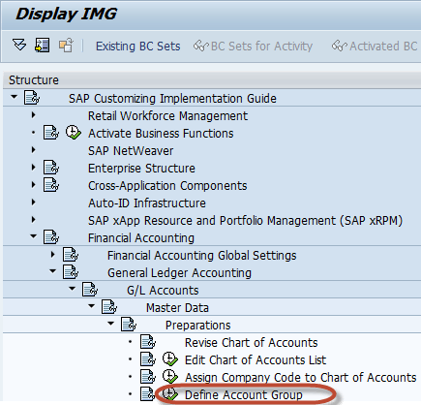](http://www.guru99.com/images/sap/2012/04/COAAgrp15.png)

In the next screen, select New Entries

[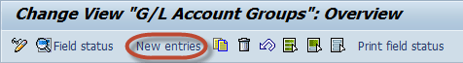](http://www.guru99.com/images/sap/2012/04/COAAgrp14.png)

In the next screen, Enter following Information

1. Enter the Chart of Accounts key in which the Account Group is to be created
2. Enter unique  Account Group key
3. Enter Description for the Account Group
4. Enter the number range for the G/L account to be created in the Account Group

[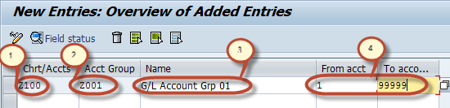](http://www.guru99.com/images/sap/2012/04/COAAgrp13.png)

select Field Status from the Application menu

[How to Create a Chart of Accounts Account Group](http://www.guru99.com/images/sap/2012/04/COAAgrp11.png)

In the next screen, you can change the field status for different sections of the G/L COA Master Data. For example select Account Control

[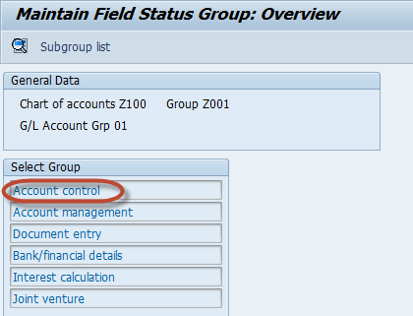](http://www.guru99.com/images/sap/2012/04/COAAgrp12.png)

Now you can maintain the status of different fields belonging to Account Control Tab  
  
between Suppressed ( Hidden ) , Required , Optional and Display modes.

[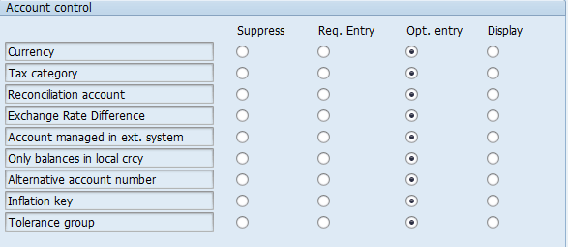](http://www.guru99.com/images/sap/2012/04/COAAgrp10.png)

**Note**:-The default status of fields is Optional.  
  
After maintaining the field status , press save [How to Create a Chart of Accounts Account Group](http://www.guru99.com/images/sap/2012/04/COAAgrp03.png) Enter your change request number

[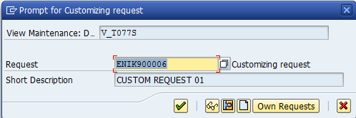](http://www.guru99.com/images/sap/2012/04/COAAgrp04.png)

You have successfully created a Chart of Accounts Account Group.

## How to Create Retained Earnings Account

This tutorial demonstrates how to create Retained Earnings Account

Enter Transaction code SPRO in the command field

[](http://www.guru99.com/images/sap/2012/04/COACR07.png)

In the next screen Select SAP reference IMG

[](http://www.guru99.com/images/sap/2012/04/COACR06.png)

In next screen-"Display IMG"  navigate the following menu path :  
  
SAP Customizing⇒Implementation Guide⇒Financial [Accounting](http://www.guru99.com/accounting.html) ⇒General Ledger Accounting⇒G/L Accounts ⇒Master Data⇒ Preparations⇒ Define Retained Earnings Account

[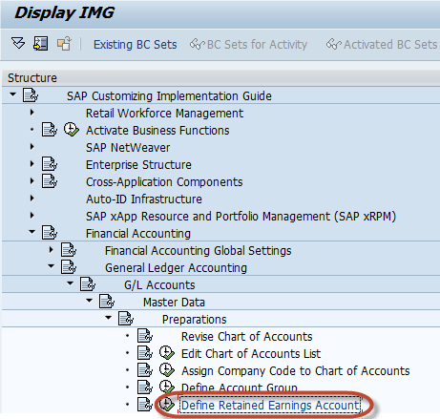](http://www.guru99.com/images/sap/2012/04/RetEarnAc08.png)

In the next screen,  Enter the Chart of Accounts to maintain the Retained Earnings Account

[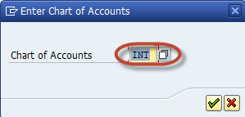](http://www.guru99.com/images/sap/2012/04/RetEarnAc07.png)

In the next screen, select New Entries from the Application Menu

[How to create Retained Earnings Account](http://www.guru99.com/images/sap/2012/04/RetEarnAc09.png)

In the next screen, Enter the following information

1. Enter the P&L statement account type, to determine the retained earnings account for each P&L account.If you are creating a P&L account, you must make an entry here.
2. Enter the G/L Account which will be considered as Retained Earnings account

[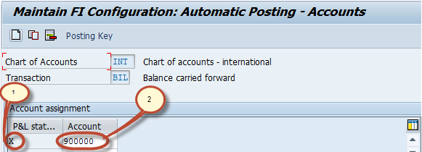](http://www.guru99.com/images/sap/2012/04/RetEarnAc06.png)

You can maintain the posting key for this account by selecting posting key in the Application Menu

[How to create Retained Earnings Account](http://www.guru99.com/images/sap/2012/04/RetEarnAc05.png)

After this you can assign posting key for Debit and Credit

[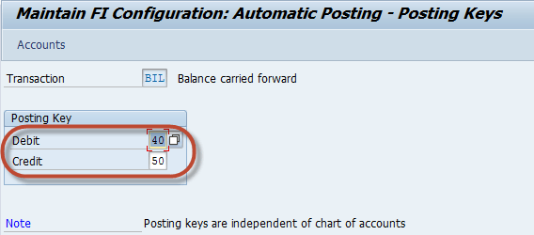](http://www.guru99.com/images/sap/2012/04/RetEarnAc04.png)

After maintaining all required information  , press save[How to Create Retained Earnings Account](http://www.guru99.com/images/sap/2012/04/COAAgrp03.png)and Enter your change request number

[](http://www.guru99.com/images/sap/2012/04/COAAgrp04.png)

You have successfully created a Retained Earnings Account.

## How to Block or Delete a G/L Account

Enter Transaction Code FS00 in SAP Command Field

[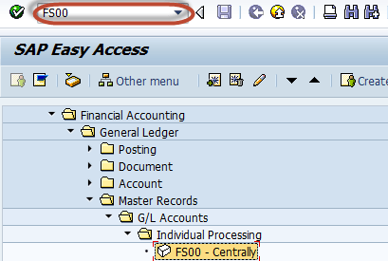](http://www.guru99.com/images/sap/2012/06/GLDelBl01.png)

In the next screen

1. Enter the G/L Account you want to block or delete
2. Enter the Company Code

[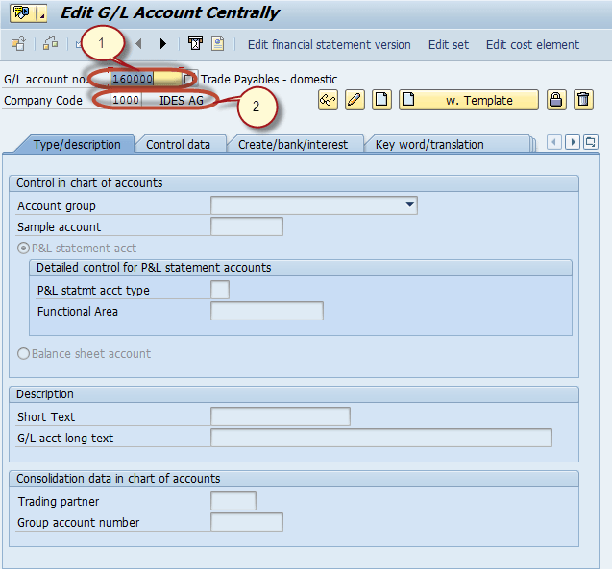](http://www.guru99.com/images/sap/2012/06/GLDelBl02.png)

**For Blocking**

In the next step , Press the Block button

[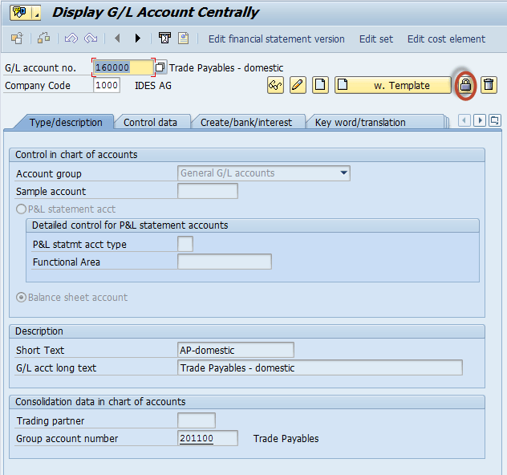](http://www.guru99.com/images/sap/2012/06/GLDelBl03.png)

In the next screen, you have the blocking options for the G/L Accounts

[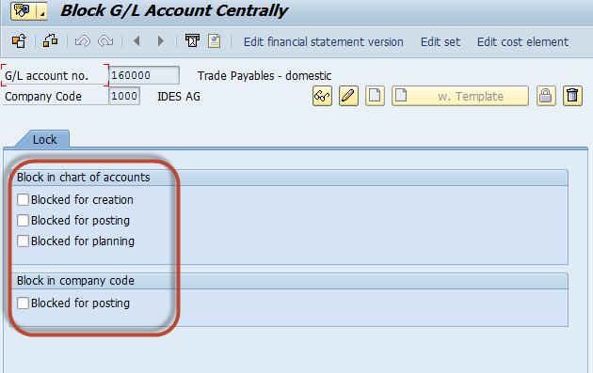](http://www.guru99.com/images/sap/2012/06/GLDelBl04.png)

**For Deleting**

In the next step , Press the Mark for deletion button

[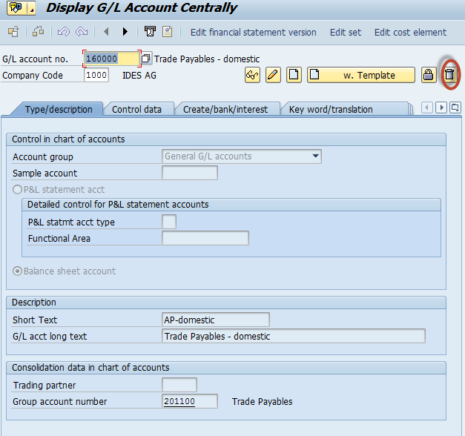](http://www.guru99.com/images/sap/2012/06/GLDelBl05.png)

In the next screen, you have the deletion options for the G/L Accounts

[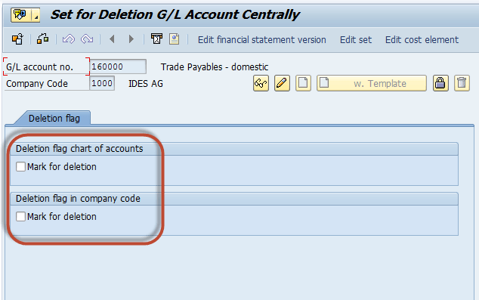](http://www.guru99.com/images/sap/2012/06/GLDelBl06.png)

## How To create a New General Ledger Account

Enter Transaction **FS00** into the SAP command prompt  , click execute**.**

[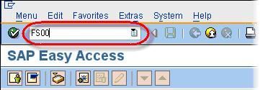](http://www.guru99.com/images/sap/2010/05/SAP-General-Ledger-Account-1.jpg)

In the Edit G/L Account Screen

1. Enter G/L Account no.
2. Company Code
3. Click Create.

Note , SAP provides you an option to  create a GL account with reference to another GL account. More on this later in the tutorial.

[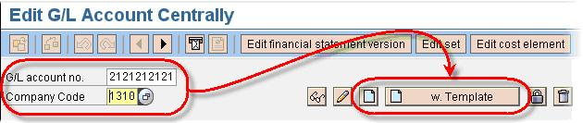](http://www.guru99.com/images/sap/2010/05/SAP-General-Ledger-Account-2.jpg)

In the next screen

1. Enter Account Group
2. As per the type of G/L Account you are creating select either the **P&L Statement Acct** or the **Balance Sheet Account** radio button.
3. In the **Short Text** field, enter a short description for the new GL account.
4. In the **G/L Acct Long Text** field, enter a detailed description for the new GL account.

[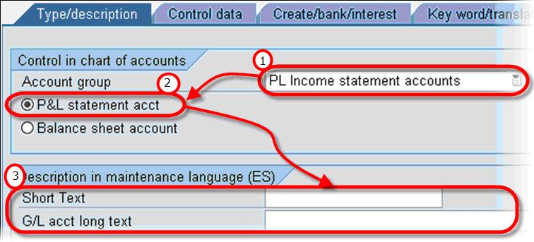](http://www.guru99.com/images/sap/2010/05/SAP-General-Ledger-Account-3.jpg)

* Click on the **Create/Bank/Interest** tab.
* In the **Field Status Group**, select a GL field status group

Click Save . A new G/L Account is created.

[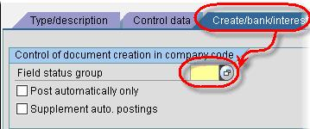](http://www.guru99.com/images/sap/2010/05/SAP-General-Ledger-Account-4.jpg)

In case you choose to create a new SAP G/L account with reference to a template

[http://cdn.guru99.com/images/sap/2010/05/SAP-General-Ledger-Account-5.jpg](http://www.guru99.com/images/sap/2010/05/SAP-General-Ledger-Account-5.jpg)

Enter a reference **G/L account no.** and **Company**

[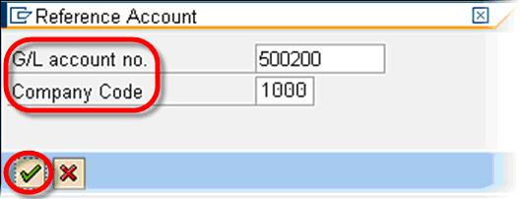](http://www.guru99.com/images/sap/2010/05/SAP-General-Ledger-Account-6.jpg)

* Change the **Short Text** and **G/L acct long text**.
* Validate the other information on the **Type/description** and **Create/bank/interest** tabs .

[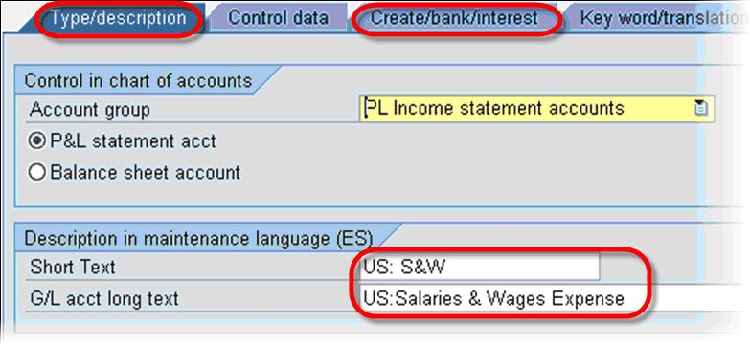](http://www.guru99.com/images/sap/2010/05/SAP-General-Ledger-Account-7.jpg)

Click Save to create the G/L Account.

## Posting to General Ledger

Posting payroll results to accounting is one of the subsequent activities performed after a successful payroll run. It usually takes place once each payroll period, as well as after each off-cycle payroll run. Once you have exited the payroll run, you need to post the payroll results to the appropriate GL accounts (including cost centres). GL psoting does the following-

* Groups together posting-relevant information from the payroll results.
* Creates summarized documents.
* Performs the relevant postings to appropriate GL accounts and cost centers

**How posting is evaluated ?**

Each employee’s payroll result contains different wage types that are relevant to accounting:

* Wage types such as standard salary, bonuses, and overtime represent **expenses** for the company, which are posted to a corresponding **expense account**.
* Wage types such as bank transfer, employment tax, employee’s contribution to social insurance, etc. are the employer’s payables to the employee, the tax office, etc. and are posted as **credits** to a corresponding**payables or**[**financial**](http://www.guru99.com/sap-fico-training-tutorials.html)**account**.
* In addition, there are wage types such as the employer’s health insurance contribution, which represents an expense for the enterprise and, at the same time, a payable to the social insurance agency. For this reason, such wage types are posted to **two accounts**- once debited as an **expense**, and once credited as a **payable**.
* Other types of wage types also exist, for example accruals, provisions, etc. These types of wage types are usually posted to two accounts, once debited as an **expense** and once credited as a **provision**.

[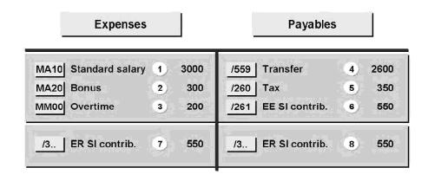](http://www.guru99.com/images/sap/2010/10/Posting-Evaluation.jpg)

Posting to General Ledger is a 2 STEP process :-

**STEP 1) Create a Posting Run**

**Transaction:**PC00_M99_CIPE

**Overview:**

* This step creates a posting run based on the payroll results, with a “distinctive number”, a “run type PP”, and the accompanying posting documents.
* The posting run ensures that payroll results for an employee are only posted once
* Processed payroll results for an employee are flagged
* If the posting run is successful, it gets the status “Documents Created”.
* If the posting run is unsuccessful, it gets the status “Incorrect Documents”. Relevant error messages will appear in the Output Log.

A posting run can be executed in 3 Modes:

* A test run without documents **(T)**
* A simulation run with simulation documents **(S)**
* A productive run **(P)**

**Test (T)**

In a test run, the system checks only whether the balance of expenses and payables is zero, as it should be.

**Simulation (S)**

In both simulation and productive runs, the system checks all [HR](http://www.guru99.com/sap-hcm.html) and RT tables and the posting information in master data to determine whether they exist and whether they are consistent.

**Productive Run (P)**

When you choose Execute Run for a productive run, the system performs the following steps:

* Selects the employees and their payroll results for the evaluation
* Creates a posting run
* Creates posting documents

**Program Input Screen**

Enter Payroll Area , Selection Criteria , Type of Document Creation , Check Ouput Log , Enter Document Date and Choose a Posting Variant. Click Execute.

[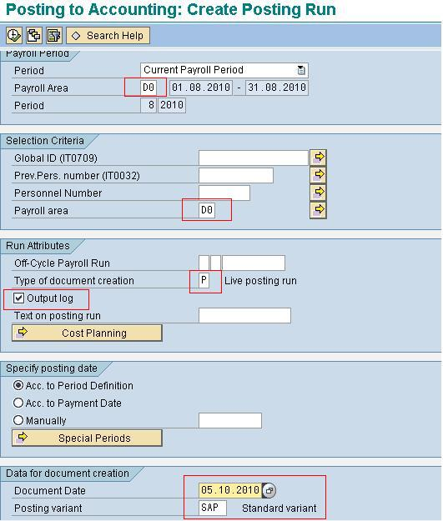](http://www.guru99.com/images/sap/2010/10/Posting-Input-Screen.jpg)

**Output Log**

* The log shows whether the posting run was successful for all personnel numbers.
* You will obtain the list of all employees selected, in “RED” (indicates errors or imbalance) or “GREEN” (indicates no errors).
* In the Output Log, if it is successful posting run, the “Doc. Creation” will indicate Error-Free. If it is unsuccessful, the “Doc. Creation” will indicate Incorrect.
* Write down the posting run number.
* If you select the **Document Overview** button or double click the **Doc. creation**line, you can access the document overview screen

[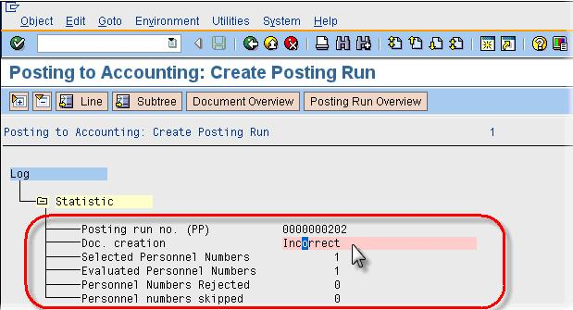](http://www.guru99.com/images/sap/2010/10/Posting-Output-Screen.jpg)

**STEP 2) Editing a Posting Run**

**Transaction**: PCP0  
**Overview:**

* This step provides an overview of ALL documents created during the posting run.
* Alternatively, you can also access the document overview from the **Create Posting Run** log by choosing the**Document Overview** button or by double clicking on the **Document Creation**line.
* You can drill-down through these documents to identify the reasons for which errors have occurred for unsuccessful posting run (i.e., with an “Incorrect” status).

**Posting Run Status**

* Initially the posting run status should be **Documents created**.
* If status is **No documents created** and you were expecting documents, go back to the previous **Create a Posting Run**step and retry.
* If there are Incorrect documents review the error message and resolve.
* Once Error are resolved and status is **Document Created** , Select Release Document Button and status will change to **All Document Released**
* Next click Post documents button , Status will change to **Documents Posted**

[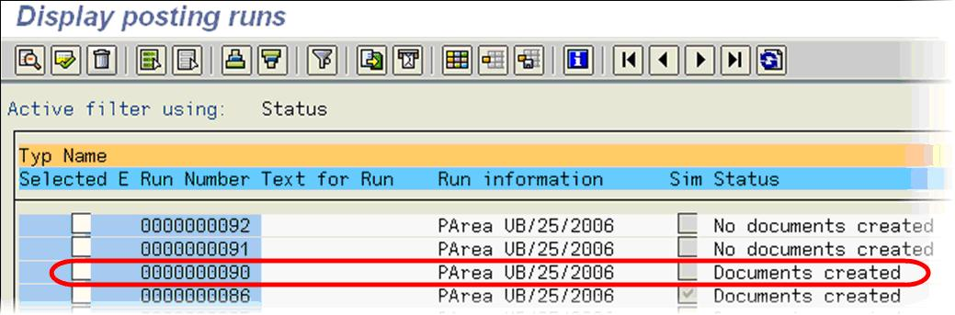](http://www.guru99.com/images/sap/2010/10/SAP-Display-Posting-Run.jpg)

## How to Display Changes in G/L Account Master

Enter the Transaction Code FS04 in the SAP Command Field

[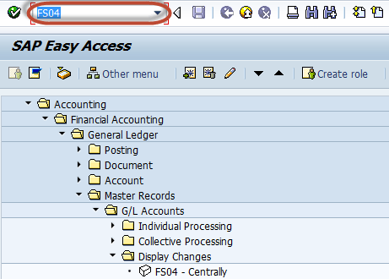](http://www.guru99.com/images/sap/2012/06/GLDISPCH04.png)

In the next screen, Enter the Following

1. Enter the G/L Account Number
2. Enter the Company Code

[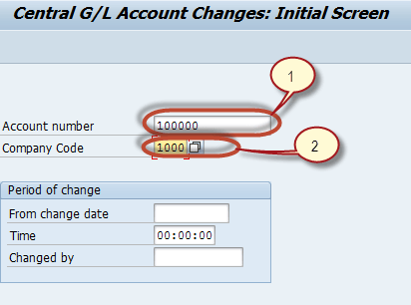](http://www.guru99.com/images/sap/2012/06/GLDISPCH03.png)

In the next screen , Select the Field from the list of Changed Fields

[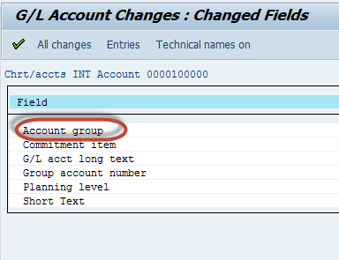](http://www.guru99.com/images/sap/2012/06/GLDISPCH02.png)

In the next screen, List is generated with New Value and Old Value of the field

[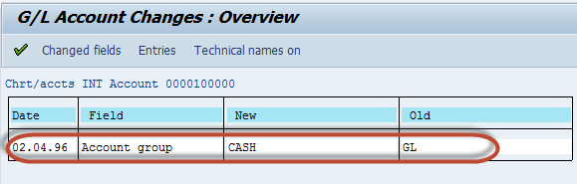](http://www.guru99.com/images/sap/2012/06/GLDISPCH011.png)

## How to create Financial Statement Version (FSV)

This tutorial takes you through the steps to create a Financial Statement Version   Enter Transaction code SPRO in the command field

[](http://www.guru99.com/images/sap/2012/04/COACR07.png)

    In the next screen Select SAP reference IMG

[](http://www.guru99.com/images/sap/2012/04/COACR06.png)

    In next screen-"Display IMG"  navigate the following menu path SAP Customizing Implementation Guide -> Financial Accounting -> General Ledger Accounting -> Business Transactions -> Closing -> Document -> Define Financial Statement Versions

[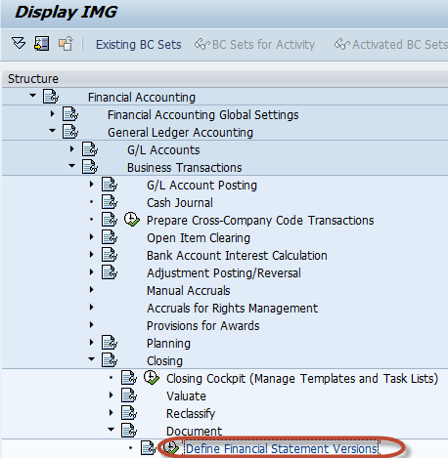](http://www.guru99.com/images/sap/2012/05/Finstver05.png)

  In the Next Screen, Select New Entries

[](http://www.guru99.com/images/sap/2012/05/Finstver22.png)

  In the Next Screen, Enter the Following

1. Enter the FSV Key
2. Enter the Description for the purpose of the FSV
3. Enter the  language key designates the language in which you Display texts,Enter texts and Print documents.
4. Enter this indicator which specifies whether keys of f.s items are assigned manually or automatically when the financial statement versions are defined.
5. If we specify a COAhere, only accounts from this chart of accounts can be assigned when you are defining the financial statement. If you do not specify a chart of accounts, accounts from several charts of accounts can be assigned when you define the financial statement.
6. Enter this Indicator that specifies that the group account numbers should be assigned instead of the account numbers when you define the financial statement version.
7. Enter this indicator as it makes possible to assign functional areas or accounts in the financial statement version.

[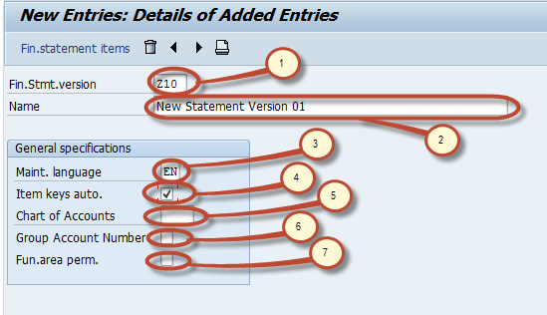](http://www.guru99.com/images/sap/2012/05/Finstver061.png)

After maintaining the fields , press save [How to create Financial Statement Version](http://www.guru99.com/images/sap/2012/04/COAAgrp03.png)   Enter your change request number

[](http://www.guru99.com/images/sap/2012/04/COAAgrp04.png)

After the Financial Statement Version is saved you can edit its structure items by selecting Financial statement items button  
[How to create Financial Statement Version](http://www.guru99.com/images/sap/2012/05/Finstver08.png)   
In the next screen, you can maintain nodes in version object A new version has  seven basic nodes by default, listed below

1. Financial Statement Notes
2. Not Assigned
3. P+L result
4. Net result : loss
5. Net result : profit
6. Liabilities+Equity
7. Assets

[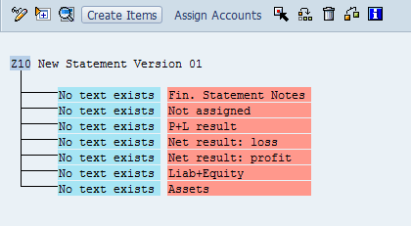](http://www.guru99.com/images/sap/2012/05/Finstver07.png)

    We can maintain node text by double clicking on the node . We can create subitems to the node by selecting the node and pressing the create items button [How to create Financial Statement Version](http://www.guru99.com/images/sap/2012/05/Finstver09.png) New item will be created as subnode to the selected node. We can assign accounts or group of Accounts to  a node by selecting the node and pressing Assign Accounts .[How to create Financial Statement Version](http://www.guru99.com/images/sap/2012/05/Finstver10.png) Below is an example of such an assignment.

1. Primary  Node "Assets"
2. Subnode "Cash & Cash Equivalents" are assigned to Assets ." Petty cash" is a subnode assigned to Cash & Cash equivalents.Other nodes are also assigned to Cash & Cash Equivalents such as : Checking,Citibank Account, Mellon Bank,Citibank Canada
3. Chart of Account key used for assigning accounts
4. Range of accounts assigned to node Petty Cash
5. Range of Accounts

[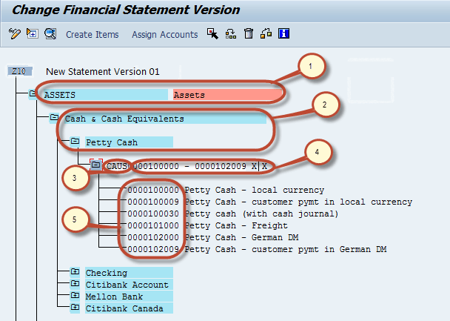](http://www.guru99.com/images/sap/2012/05/Finstver031.png)

 After Maintaining the structure press Save  [How to create Financial Statement Version](http://www.guru99.com/images/sap/2012/04/COAAgrp03.png) and we have successfully created a Financial Statement Version.

## How to perform a Journal Entry Posting in SAP

This tutorial will take you through the steps involved in Posting a Journal Entry  
  
We will take a sample business transaction for the posting.  
  
Post General Ledger 5000 units of local currency are drawn from the house bank account in cash and put into petty cash.  
  
Enter the transaction code FB50

[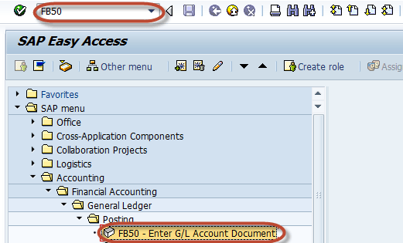](http://www.guru99.com/images/sap/2012/05/Finpost07.png)

In the next screen, Enter the document date in header part

[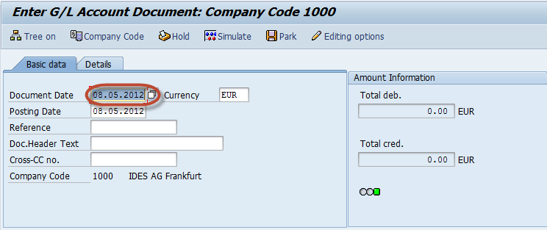](http://www.guru99.com/images/sap/2012/05/Finpost05.png)

Next select button Company Code

[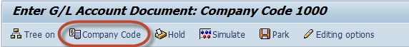](http://www.guru99.com/images/sap/2012/05/Finpost09.png)

Enter the Company Code for the Transaction

[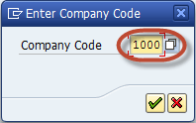](http://www.guru99.com/images/sap/2012/05/Finpost06.png)

In the Item details part , Enter the following

1. Enter Cash Account to be Debit
2. Select  Debit
3. Enter Amount to be debited
4. Enter Bank account to be Credited
5. Select Credit
6. Enter Amount to be Credited

[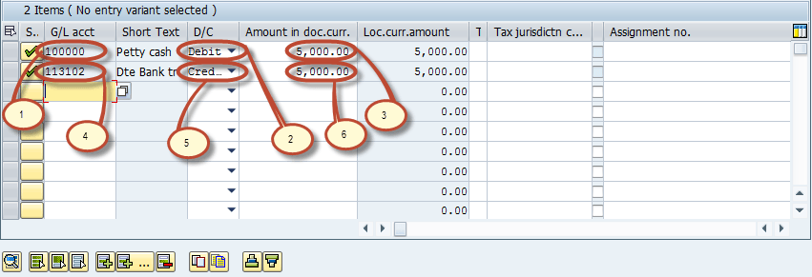](http://www.guru99.com/images/sap/2012/05/Finpost04.png)

Now check the status of the Document in Amount Information section

[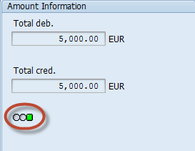](http://www.guru99.com/images/sap/2012/05/Finpost08.png)

In the Status Bar Document number is generated which confirms Document Posting.

## How to Create a Fiscal Year Variant

Enter the Transaction code SPRO in the SAP Command Field and Press Enter

[How to create a fiscal year variant](http://www.guru99.com/images/sap/2012/05/FYVaraint01.png)

In the next screen Select SAP reference IMG

[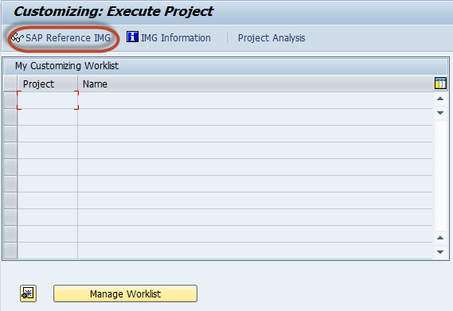](http://www.guru99.com/images/sap/2012/05/FYVaraint02.png)

In next screen-"Display IMG" navigate the following menu path :

SAP Customizing Implementation Guide Financial Accounting -> Financial Accounting Global Settings->Fiscal Years -> Maintain Fiscal Year Variant (Maintain Shortened Fiscal Year )

[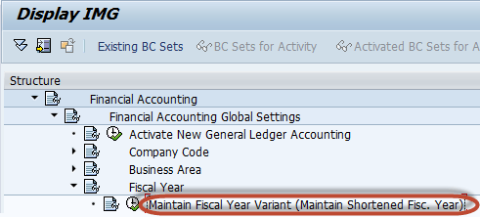](http://www.guru99.com/images/sap/2012/05/FYVaraint03.png)

In the next screen, Select "New Entries" from the Application Toolbar

[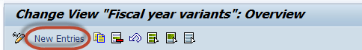](http://www.guru99.com/images/sap/2012/05/FYVaraint04.png)

In the next screen , Enter the following Data

1. Enter two digit unique fiscal year variant key
2. Enter a Description for Variant created.
3. If Fiscal Year is year dependent , that is if start and end dates for fiscal year changes between year, then select this option, normally it is used for shortened fiscal year.
4. If Fiscal Year is same as calendar year , that is Jan - Dec , then select this option.
5. Enter the number of posting periods for this fiscal year
6. Enter the number of special posting periods for this Fiscal year, that is used for closing activities.

[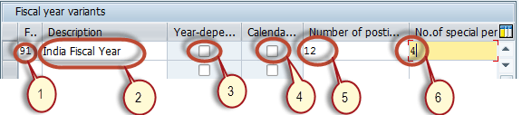](http://www.guru99.com/images/sap/2012/05/FYVaraint05.png)

After entering all required data , Press Save from the standard toolbar

[How to create a fiscal year variant](http://www.guru99.com/images/sap/2012/05/FYVaraint06.png)

In the next screen, Enter the customizing request number and you have created a new Fiscal year Variant

[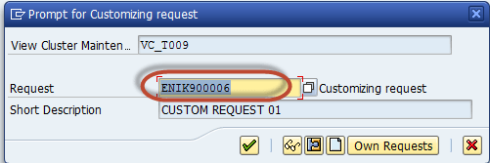](http://www.guru99.com/images/sap/2012/05/FYVaraint07.png)

For Maintaining the period dates , that is if the Fiscal year Variant is not Calendar Year, then we can maintain the Posting period by

1. Select the Fiscal Year Variant you want to maintain the period
2. Select the Periods folder

[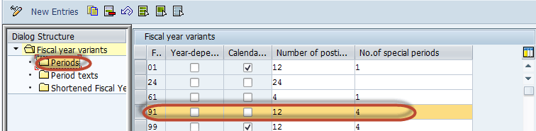](http://www.guru99.com/images/sap/2012/05/FYVaraint08.png)

In the next screen , Maintain the periods for the Fiscal year in Ascending order

[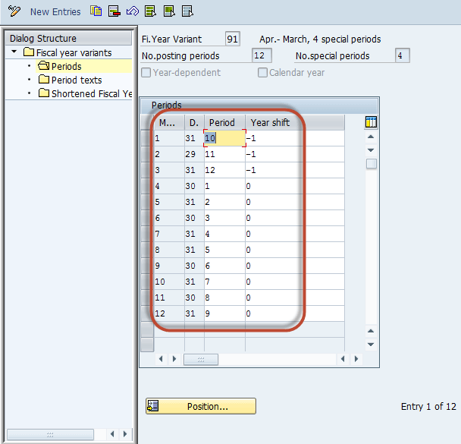](http://www.guru99.com/images/sap/2012/05/FYVaraint09.png)

After maintaining the periods , Press "Save" in SAP Standard Toolbar